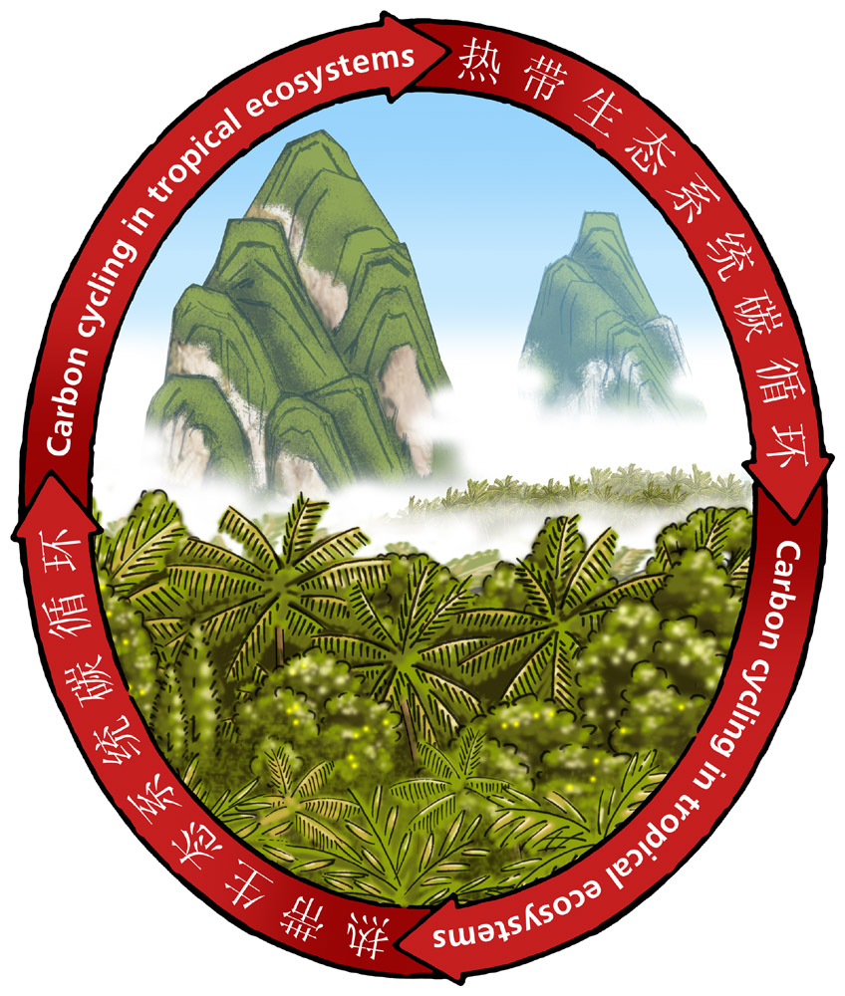
Planning Questionnaire of 23rd New Phytologist Symposium Carbon cycling in tropical ecosystems

Guangzhou, China
17-20，Nov. 2009
Please print or type and return this form before 31 March 2009
1. Title: □ Dr. □ Prof. □ Ms. □ Mrs.
□ Mr. □ Other
2. Last name（in Chinese）: __________________________________________
First name（in Chinese）: _________________________________________
3. Sex: □ Male □ Female
4. Country: ___________________________________________
5. Postal address:
_________________________________________________
_________________________________________________
6. Telephone No: _______________________________________
Mobile phone No: ____________________________________
Fax: _______________________________________________
E-mail: ____________________________________________
7. Employer's name and address:
__________________________________________________
__________________________________________________
8. I intend to give □poster on the topic of:
__________________________________________________
__________________________________________________
9. Number of accompanying persons: □
10. Signature: ____________________. Date: _______________
联系人：
广州市天河区兴科路723号
中国科学院华南植物园，余艳, 510650
Phone: 020-37252712,
Fax ：020-37252831,
E-mail: yuyan@scbg.ac.cn

